Tips & Tools

- KNOW THE LOCAL TRAIL RULES.

- COURTESY IS SYNONYMOUS WITH SAFETY ON THE TRAILS.

- RESPECT OTHERS, THE LAND, & WILDLIFE. LEAVE NO TRACE.

- LEAVE GATES AS YOU FIND THEM. OBEY GATE CLOSURES AND REGULATORY SIGNS.

- SAY HELLO. ALERT OTHERS WHEN COMING UP FROM BEHIND. PASS WITH CARE.

- KEEP TO THE RIGHT. PASS TO THE LEFT. CALL OUT BEFORE PASSING.

- MAINTAIN A SAFE AND CONTROLLED SPEED.

- BE ESPECIALLY CAREFUL WHEN VISIBILITY IS LIMITED.

- AS A WARNING FOR OTHERS TO SLOW DOWN OR STOP, EXTEND YOUR ARM, WITH YOUR HAND OUT AND DOWNWARD.

- MINIMIZE YOUR FOOTPRINT IMPACT BY STAYING ON DESIGNATED TRAILS.

- KNOW YOUR HORSE’S LIMITATIONS AND YOUR SKILL LEVEL.

Additional Resources

Please contact the groups below for additional information.

Virginia Department of Agriculture
www.vdacs.virginia.gov
(804) 786-3501

Virginia State Parks
http://www.dcr.virginia.gov/state-parks/

Virginia Horse Trails
www.vahorsetrails.org

Virginia Department of Game and Inland Fisheries
www.dgif.virginia.gov/hunting/regulations
(804) 367-1000

Equestrian Land Conservation Resource
www.elcr.org
(859) 455-8383

Enjoy the Trails!

*Some information courtesy of the Connecticut Horse Council.

TRAIL ETIQUETTE

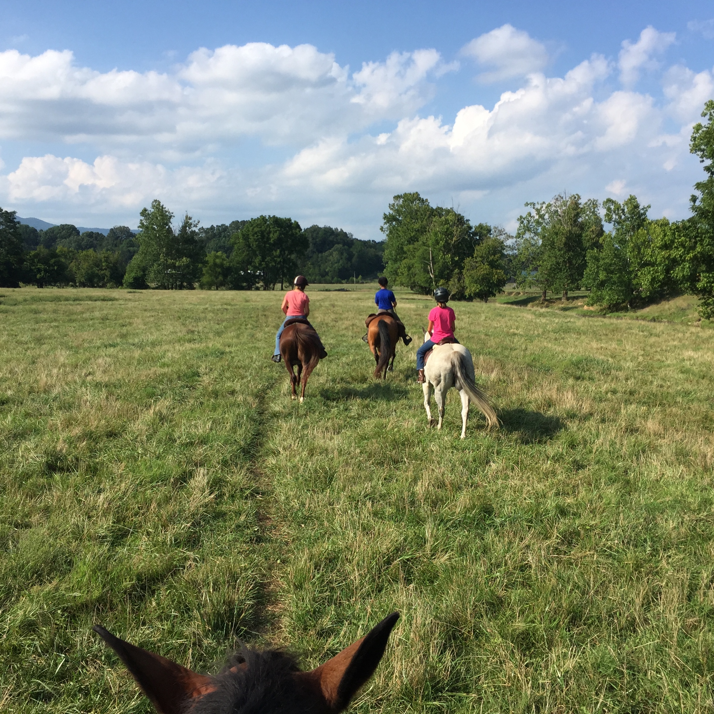

Brochure compliments of
Ardmore Equestrian Center
13 Breckenridge Mill Road
Fincastle, VA 24090
(678) 603-9458
ardmoreequestriancenter@gmail.com

The Commonwealth of Virginia has a beautiful system of trails through its state parks and forests. We also have a large population of horses, many of which are ridden on these trails.

Ardmore Equestrian Center would like to remind riders that they are ambassadors for our industry. Every time you ride, you need to act responsibly, otherwise we could find horses restricted from trails in the future, as has happened in other states. Often, misunderstandings occur because riders are unaware of certain rules.

Treat the trail with respect

Discourage your horse from snacking. Some plants may be toxic to horses; others could be endangered species. Eating and trampling vegetation leads to bare dirt, which leads to destroyed vegetation and polluted streams. Do not tie horses directly to trees, as they may chew on the bark, causing damage. Minimize soil impact by staying on designated trails and avoiding muddy conditions.

Many horses will move slightly to the side to relieve themselves, (or they can be trained to do so). The responsible trail user will try to keep his horse’s end products away from high traffic multiple-use areas. If a horse is trained to keep moving while defecating, the material will biodegrade within days (because equines are herbivores) and with less environmental impact. In rare cases, on well used multiple-use trails and Greenways, it’s a good idea to dismount and move the manure over to the side. Deep hoof prints and manure are the two biggest concerns of other trail users.

Don’t smoke on the trail. Don’t litter. Keep the trailhead clear of manure and trash. Be environmentally responsible, and trail-train your horse. Your goal is to

Leave No Trace…

Hunting

Hunters have the right to be in the woods during designated hunting seasons. Dates of various game seasons are available from the Virginia Department of Game and Inland Fisheries (DGIF). It’s best to avoid actively hunted areas when riding. If you must ride in areas where hunting is allowed, be aware that hunters may be hunting with a dog or from a boat or blind. Gunshots are to be expected and WILL spook a horse. Be cautious when riding on dirt roads or in fields.

Hunting on Sundays is now allowed under certain circumstances.
Sunday Hunting in Virginia

** During hunting season, riders, cyclists, hikers and joggers should wear bright or blaze orange, (never white), carry bells; be seen and heard**

Other Issues

Often, private property abuts state forests and parks. Riders need to be aware of their locations on trails, and should NEVER trespass on private property, whether it is posted or not. Private property is not required to be posted, and you can be prosecuted for being there. Maps of public trails can be obtained from your city or county public recreation departments.

Know your skill level and your horse’s capabilities

Many trails have terrain and obstacles that may be more difficult for both you and your horse. Some well used Greenways may be popular for joggers, fast riding bicyclists, dogs that may not be under control, etc. Stay alert for potential problems.

On high traffic trails with multiple surfaces, stay to the right except when passing. It may be safer to dismount and lead your horse across some bridges.

Standard multiple-use trail regulations give equestrians the right of way. Mountain bikes yield to hikers, and both cyclists and hikers yield to horses. As the privileged user, this means it’s up to the equestrian to think safety at all times, take control of encounters with others, and be diplomatic and polite.

Everyone who uses trails should also keep track of the time, and make every effort to be back before dark. Most state forests and parks close at dusk, and the risks of riding in the dark are great. Think Safety!

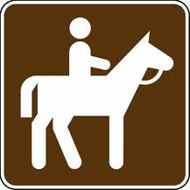

It is important to remember that your actions reflect on the entire industry, and you are responsible for knowing the rules of the trails on which you are riding. Every precaution you take protects you, your horse, and other trail users.

