Tips & Tools

- Annually review all policies to ensure your coverage is adequate for your needs.

- Do not rely on state laws alone to protect you. Laws change and they may not protect you in every case.

- Read your policy completely and ask your agent if you have questions. Sometimes you are required to take certain actions in order for coverage to be in effect.

- Never make assumptions that your policy will cover something. Read your policy and know what coverage you have.

- Do not rely solely on insurance to protect you. You still have a duty to act in a safe manner.

- Take photos of animals and property and record serial numbers, brands and registration numbers. This will make it easier to file a claim after a loss.

- Consider micro-chipping animals and etching or marking property.

- Use releases and waivers drafted by a qualified attorney. Always use a contract when entering into a business agreement of any sort.

- Obtain multiple quotes from different agencies in order to compare prices and available coverage.

- If you have independent trainers/instructors who work on your property, consider having them carry their own liability insurance with you as a “named insured”.

Additional Resources

This brochure is meant as a guideline only and should not be construed as legal advice. If you have further questions, please consult with an attorney or licensed insurance agent.

Virginia Department of Insurance
www.scc.virginia.gov/boi
(800) 552-7945

A.M Best Company (provides ratings of insurance companies) www.ambest.com
(908) 439-2200

National Association of Insurance Commissioners (NAIC) www.naic.org
(816) 842-3600

*Some information courtesy of the Connecticut Horse Council.

HORSES &
INSURANCE

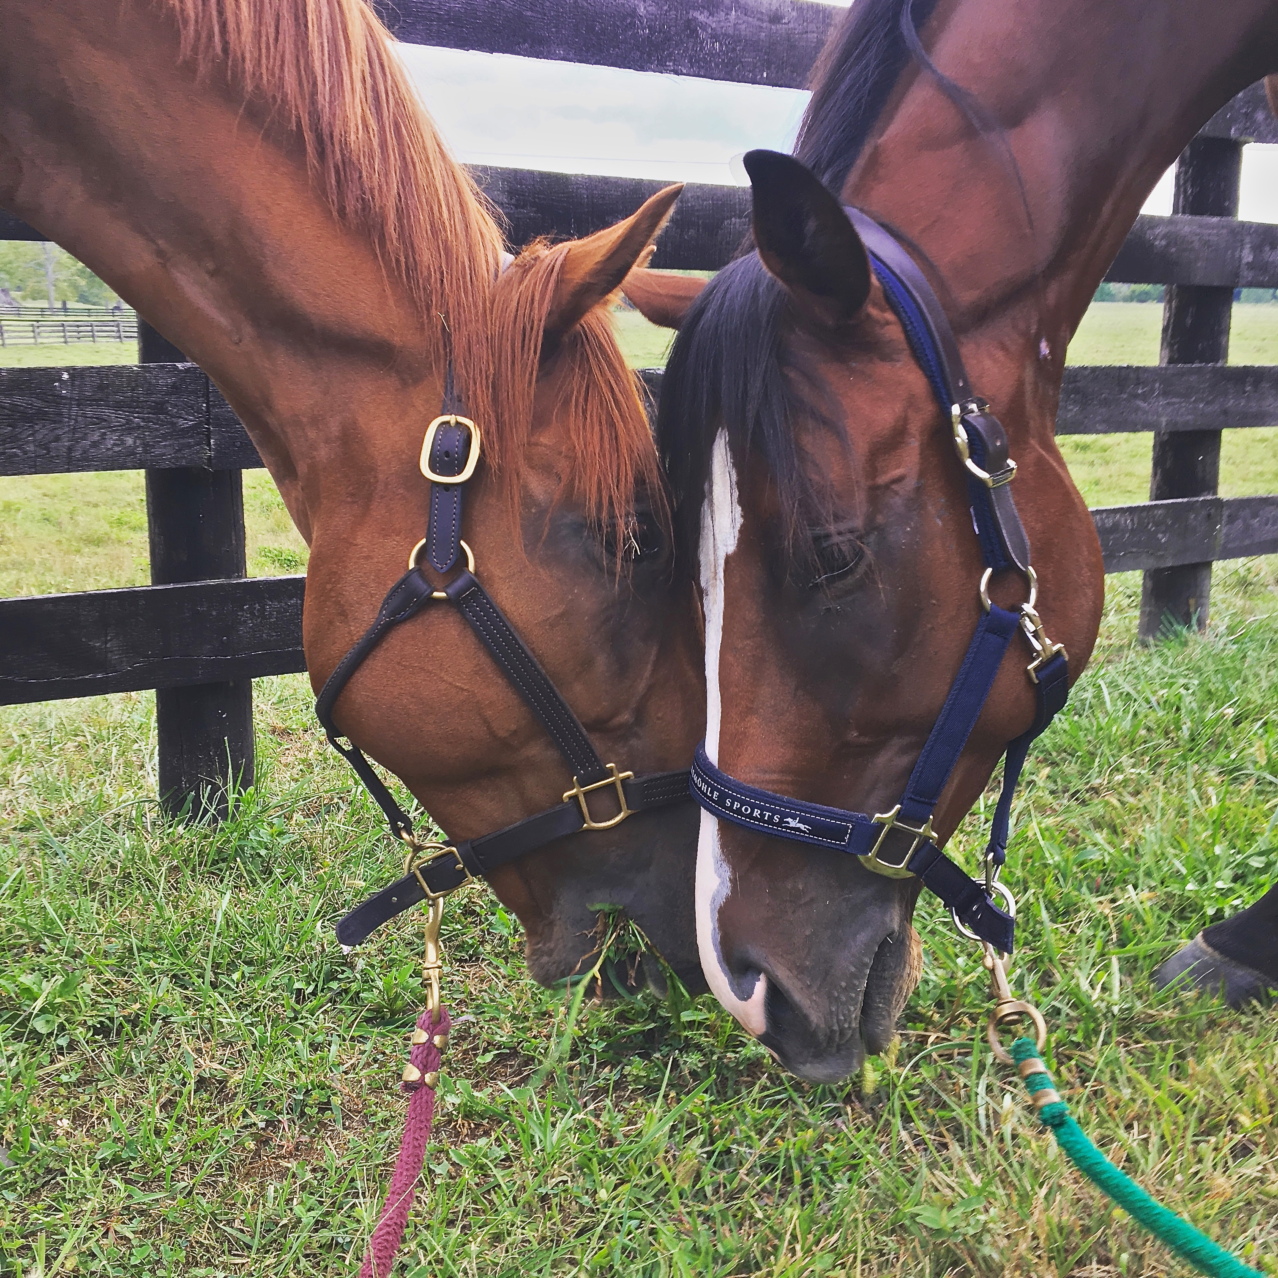

Brochure compliments of
Ardmore Equestrian Canter
13 Breckenridge Mill Road
Fincastle, VA 24090
(678) 603-9458
ardmoreequestriancenter@gmail.com

There are many different insurance companies and many different types of insurance available to horse owners in the Commonwealth of Virginia. Horse owners should be aware that even though there are a few state laws that will protect you from liability in certain instances, they will not protect you in every situation. Additionally, laws can be updated, changed or eliminated altogether, so you should consider purchasing insurance in order to protect yourself. Furthermore, you should never assume that your homeowner’s policy provides coverage for equine related liability. Many homeowners policies will not cover horses.

Types of Insurance

Most people know that there are basic types of insurance such as homeowners, automobile and commercial polices. In the world of agricultural insurance there are also policies that cover equine medical and mortality as well as general liability.

Equine mortality insurance pays for the insured value of the horse if it should die or needs to be humanely destroyed. Occasionally, owners of a leased horse will require the leasee to take out a mortality policy on the horse which is payable to the owner should the horse die during the lease period. Some companies require that a medical policy also be in effect in order to purchase a mortality policy. Often, these policies can include a “loss of use” provision, which provides coverage in case the horse is injured to the point where it can no longer perform its intended job. For example a racehorse that shatters a leg, but lives, might not be able to race again. Mortality policies typically do not have deductibles.

A medical policy will cover veterinary bills incurred if a horse becomes ill or injured. Generally, medical policies will have a deductible, and general exclusions, much like human medical policies do.

General liability policies are useful for barn and horse owners, trainer and person leasing a horse. They are designed to provide protection in the event a horse does damage or injures someone and you are sued. In Virginia you can be held liable for the actions of your horse. Just because we have an equine liability law does not mean you cannot be sued. Without liability coverage you will have to pay damages and legal defense costs yourself.

If you operate an equine business and have employees, you should also carry workmen’s compensation insurance because employees will not be covered under your general liability policy.

Choosing a Policy

Not all policies cover the same things, so make sure you investigate different companies before you make a purchase.

Often coverage will depend on a number of things including; the environment you keep your horse in (boarded or at home), what your horse is being used for, and the age and health of your horse.

The amount you pay for insurance, called a “premium”, will vary not only based on the above information but also by your location, deductible amounts and the coverage amounts you choose.

You should carefully consider what the intent of the insurance is: for example, to cover the replacement value of your horse, to cover the expenses in case of a lawsuit, or to reimburse an owner of a leased horse for its value should it be injured or die.

Many policies require that when you make a claim you must first pay a “deductible”. A deductible is the amount you will pay out of pocket before the insurance policy provides coverage. Consider what amount you can afford to pay. Often, if you choose a higher deductible amount it will lower the amount you pay for insurance premiums.

Many insurance companies will offer a discount if you have more than one policy with them. When shopping for insurance you should ask for different quotes using different deductibles, different coverage amount and inquire about multi-policy discounts.

Other Considerations

Regardless of the insurance coverage you may have, you should still take safety seriously. An insurance policy will not cover you for willful illegal acts or acts which can be considered as causing intentional harm.

Certain policies also require that you take certain actions if an event happens or they require that you take precautions before an event happens. You need to read and understand your policy at the time of purchase.

You should also make safety a priority in your barn – have students wear appropriate shoes, use signed release for all activities and make sure any business agreement is formally written in a contract.

You should also document what you have insured and keep copies in a safe location away from potential fire or water damage. Take photos of horses and make copies of registration papers. Your preparations can help prevent stress and additional losses.

